

**Project Name:**

**FOOD DELIVERY MANAGEMENT SYSTEM**

**Course Name: Introduction to Database**

**Course Teacher:**

**RIFAT TASNIM ANANNYA**

**Section: I**

**Members**

|  |  |
| --- | --- |
| **Name** | **ID** |
| Alam Rifat Bin | 17-34529-2 |
| Sadat Ebne Mahmud | 17-34648-2 |
| Hossain, Shahriar | 17-34702-2 |
| Hasnain, Md. Rafi | 16-32979-3 |
| Riaz, Abdul Al Mahmud | 18-36989-1 |

**PROJECT STORY**

Any Customers can order food in online. Every order has a **Unique Id**, **Time** and **type**.

For order food customer need to input **Name**, **Phone Number** and **Address**.

Every customer has a unique **Customer Id**. Customer can select food with **Quantity** and customer can see **Food Name** and **Price**. Customer can select **Restaurant Name**. After submission, restaurant takes the order. Employee collect order from customer. Every employee has **Name**, **Phone Number**, **Salary** and **Unique Id**.

Employee take **Order** and **Deliver**. Delivery food has a **Unique Id** and **Arrival Time.**

Customer can pay bill by **Cash on Delivery** or **Bkash** and have a unique **Payment** **Id** and can select **Payment Type**.

**ER DIAGRAM**

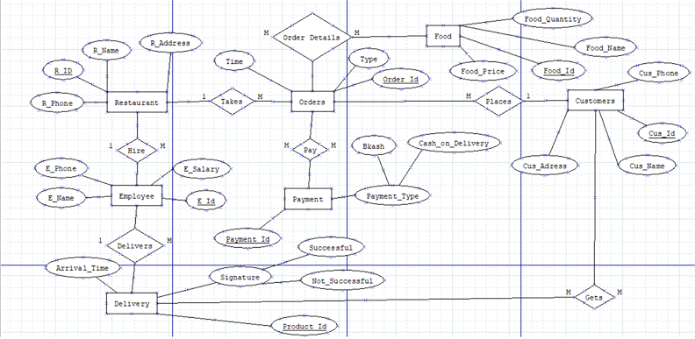

**NORMALIZATION**

Food-*-Order Details-*-Order

* **UNF:**

Order Details ( food_id, food_name, price, quantity, order_id, type, time)

* **1NF:**

There is no multivalued attribute.

* **2NF:**

(order_id, type, time, food_id)

(food_id, food_name, price, quantity)

* **3NF:**

Type (type_id, type _name)

Orders (order_id, time, type_id, food_id)

CUSTOMER-1-PLACES-*-ORDERS

* **UNF:**

Places(cus_id, cus_name, phone, address, order_id, time, type)

* **1NF:**

There is no multivalued attributes.

* **2NF:**

(order_id, time, type, cus_id)

(cus_id, cus_name, phone, address)

* **3NF:**

Type (type_id, type _name)

Contact (con_id, phone, address)

Customer (cus_id, cus_name, con_id)

Orders (order_id, time, type_id, cus_id)

RESTAURANT-1-TAKE-*ORDERS

* **UNF:**

Take(R_id, R_name, phone, address, order_id, type, time)

* **1NF:**

There is no multivalued attribute.

* **2NF:**

(R_id, R_name, phone, address, order_id)

(order_id, type, time)

* **3NF:**

Type (type_id, type _name)

Rinfo (Rinfo_id, R_address, phone)

Order (order_id, time, type_id)

Restaurant (R_id, R_name, Rinfo_id, order_id)

RESTAURANT-1-HIRE-*-EMPLOYEE

* **UNF:**

Hire (R_id, R_name, phone, address, emp_id, name, phone, salary)

* **1NF:**

There is no multivalued attribute.

* **2NF:**

(R_id, R_name, phone, address, emp_id)

(emp_id, name, phone, salary)

* **3NF:**

Rinfo (Rinfo_id, R_address, phone)

Empinfo (empinfo_id, phone, salary)

Employee (emp_id, name, empinfo_id)

Restaurant (R_id, R_name, Rinfo_id, emp_id)

ORDERS-*-HAVE-*-PAYMENT

* **UNF:**

Have (Order_id, type, time, Payment_id, payment type)

* **1NF:**

There is no multivalued attribute.

* **2NF:**

(Order_id, type, time, Payment_id)

(Payment_id, payment_type)

* **3NF:**

Type (type_id, type _name)

Payment (Payment_id, payment_type)

Orders (Order_id, time, type_id, payment_id)

CUSTOMER-*-GETS-*-DELIVERY

* **UNF:**

Gets (cus_id, cus_name, phone, address, product_id, arrival time, signature)

* **1NF:**

There is no multivalued attribute.

* **2NF:**

Customer (cus_id, cus_name, phone, address, product_id)

Delivery ( product_id, arrival time, signature)

* **3NF:**

Customer (cus_id, cus_name, con_id)

Contact (con_id, phone, address)

Delivery ( product_id, arrival time, signature)

Customer (cus_id, cus_name, con_id, product_id)

EMPLOYEE-1-DELIVERS-*-DELIVERY

* **UNF:**

Delivers (emp_id, name, phone, salary, product_id, arrival time, signature)

* **1NF:**

There is no multivalued attribute.

* **2NF :**

(emp_id, name, phone, salary, product_id)

(product_id, arrival time, signature)

* **3NF:**

Empinfo (empinfo_id, phone, salary)

Employee (emp_id, name, empinfo_id)

(product_id, arrival time, signature)

Employee (emp_id, name, empinfo_id, product_id)

**TABLE CREATION**

1. **Type** (type_id, type_name)
2. **Food** (Food_id, food_name, food_price, food_quantity, type_id)
3. **Contact** (con_id, con_phone, con_address)
4. **Resinfo** (Res_info_id, Res_info_address, res_info_phone)
5. **Emp_info** (Empinfo_id, Emp_info_phone, Emp_info_sal)
6. **Payment** (Payment_id, Payment_type)
7. **Delivery** (Product_id, arrival_time, signature)
8. **Customer** (Cus_id, cus_name, con_id, product_id)
9. **Employee** (employee_id, employee_name, empinfo_id, product_id, Rinfo_id)
10. **Order1** (order_id, time, food_id, type_id, cus_id, payment_id)
11. **Restaurant** (R_id, R_name, Res_info_id, Employee_id, order_id)

**1.CREATE TABLE TYPE (TYPE_ID NUMBER (15) NOT NULL, TYPE_NAME VARCHAR2(20) NOT NULL, PRIMARY KEY (TYPE_ID));**

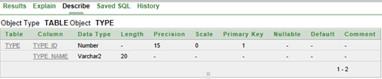

**2. CREATE TABLE FOOD (FOOD_ID NUMBER(15) NOT NULL, FOOD_NAME VARCHAR2(20) NOT NULL, FOOD_PRICE NUMBER(6) NOT NULL, FOOD_QUANTITY NUMBER(5), PRIMARY KEY(FOOD_ID));**

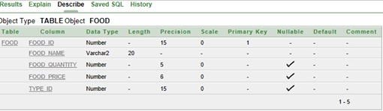

**3. CREATE TABLE CONTACT (CON_ID NUMBER(15) NOT NULL, CON_ADDRESS VARCHAR2(20) NOT NULL, CON_PHONE NUMBER(11) NOT NULL, PRIMARY KEY (CON_ID));**

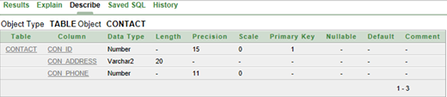

**4. CREATE TABLE CUSTOMER (CUS_ID NUMBER(15) NOT NULL, CUS_NAME VARCHAR2(20) NOT NULL, CON_ID NUMBER(15) NOT NULL, PRIMARY KEY (CUS_ID));**

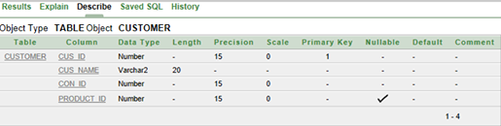

**5. CREATE TABLE RES_INFO (RES_INFO_ID NUMBER(15) NOT NULL, RES_INFO_ADDRESS VARCHAR2(20) NOT NULL, RES_INFO_PHONE NUMBER(15) NOT NULL, PRIMARY KEY (RES_INFO_ID));**

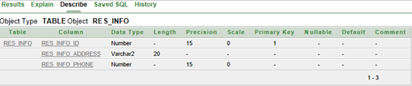

**6. CREATE TABLE EMP_INFO (EMP_INFO_ID NUMBER(15) NOT NULL, EMP_INFO_SAL DECIMAL(7,2) NOT NULL, EMP_INFO_PHONE NUMBER(15) NOT NULL, PRIMARY KEY (EMP_INFO_ID));**

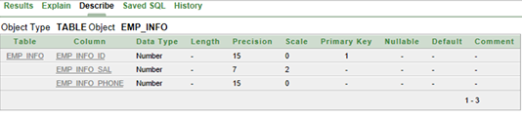

**7. CREATE TABLE EMPLOYEE (EMPLOYEE_ID NUMBER(15) NOT NULL, EMPLOYEE_NAME VARCHAR2(20) NOT NULL, EMP_INFO_ID NUMBER(15) NOT NULL, PRIMARY KEY (EMPLOYEE_ID));**

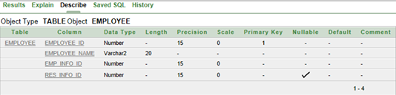

**8. CREATE TABLE PAYMENT (PAYMENT_ID NUMBER(15) NOT NULL, PAYMENT_TYPE VARCHAR2(20) NOT NULL, PRIMARY KEY (PAYMENT_ID));**

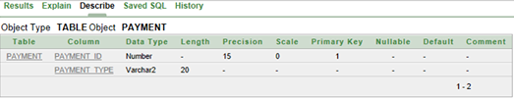

**9. CREATE TABLE DELIVERY (PRODUCT_ID NUMBER(15) NOT NULL, ARRIVAL_TIME NUMBER (5) NOT NULL, SIGNATURE VARCHAR2(20), PRIMARY KEY (PRODUCT_ID));**

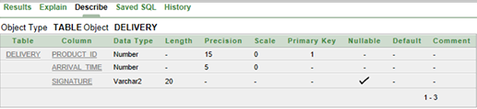

**10. CREATE TABLE ORDER1 (ORDER_ID NUMBER(15) NOT NULL, TIME NUMBER(6) NOT NULL, FOOD_ID NUMBER(15) NOT NULL, TYPE_ID NUMBER(15) NOT NULL , CUS_ID NUMBER(15) NOT NULL, PAYMENT_ID NUMBER(15) NOT NULL, PRIMARY KEY(ORDER_ID));**

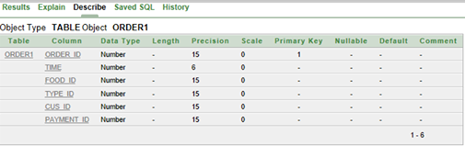

**11. CREATE TABLE RESTAURANT (R_ID NUMBER(15) NOT NULL, R_NAME VARCHAR2(20) NOT NULL, RES_INFO_ID NUMBER(15) NOT NULL, EMPLOYEE_ID NUMBER(15) NOT NULL, ORDER_ID NUMBER(15) NOT NULL, PRIMARY KEY(R_ID));**

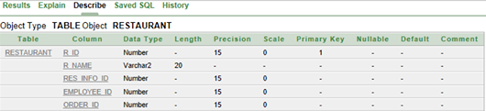

**SUB QUERY**

**Single Row subquery**

1. **Write a query to display the salary and phone number of employees where employees’ salaries are greater than employee id is 1222.**

* SELECT emp_info_sal, emp_info_phone FROM EMP_INFO WHERE emp_info_sal> (SELECT emp_info_sal FROM emp_info where emp_info_id=1222)

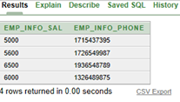

**2. Display the food and quantity of the food where food quantity is less than food id= 2055.**

* SELECT Food_name, Food_quantity from food where Food_quantity< (select Food_quantity from food where food_id=2055)

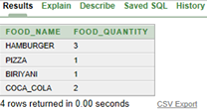

**Multiple Row Subquery**

1. **Create a query that will display the food where price is greater than food_id=’2011’, ’2022’, ’2033’, ’2044’, ’2055’.**

* SELECT food_name FROM food WHERE food_price > ANY (SELECT food_price FROM food WHERE food_id in (‘2011’, ’2022’, ’2033’, ’2044’, ’2055’)

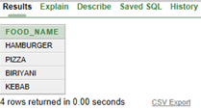

1. **Create a query that will display contact address where contact phone number match contact id=’5555’, ’5556’, ’5666’, ’6666’.**

* SELECT con_address FROM contact WHERE con_phone in (SELECT con_phone FROM contact WHERE con_id in (5555, 5556, 5666, 6666)

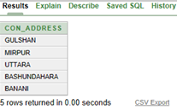

**JOINING**

**EQUI JOIN**

1. **Write a query to display the employee names from each restaurant.**

* SELECT R.R_name, E.employee_name FROM restaurant R,employee E

WHERE R.employee_id=E.employee_id

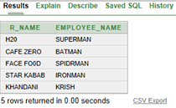

1. **Create a query that will display the customer name, arrival time and signature.**

* SELECT C.cus_name, D.arrival_time, D.signature FROM customer C, delivery D

WHERE C.product_id=D.product_id

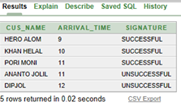

**SELF JOIN**

1. **Create a query that will display food name, food price according to same table.**

* SELECT f.food_name, k.food_price FROM food f ,food k WHERE f.food_id=k.food_id

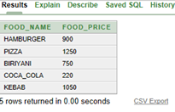

**CONSTRAINTS**

* **Check Constraint:**

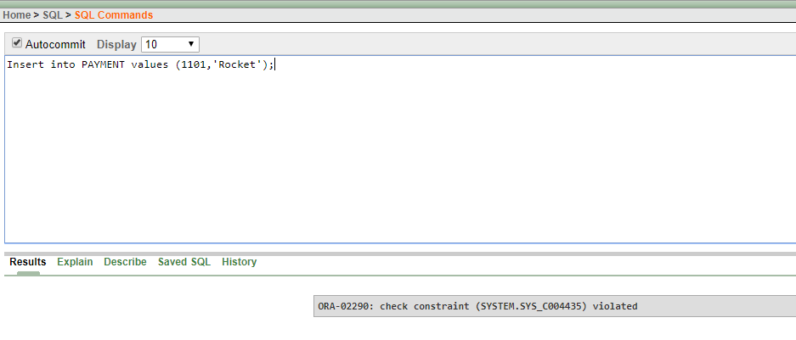

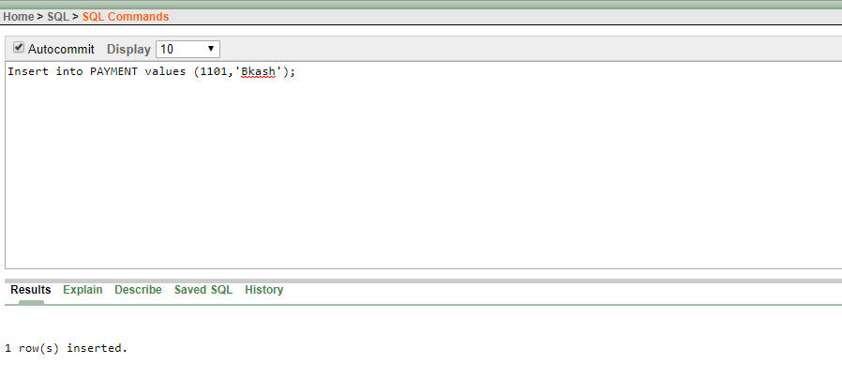

* **Primary key and Unique constraint:**

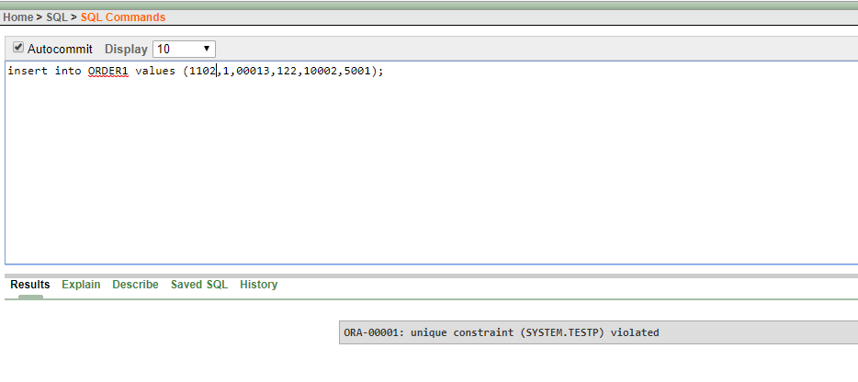

* **Disable constraint:**

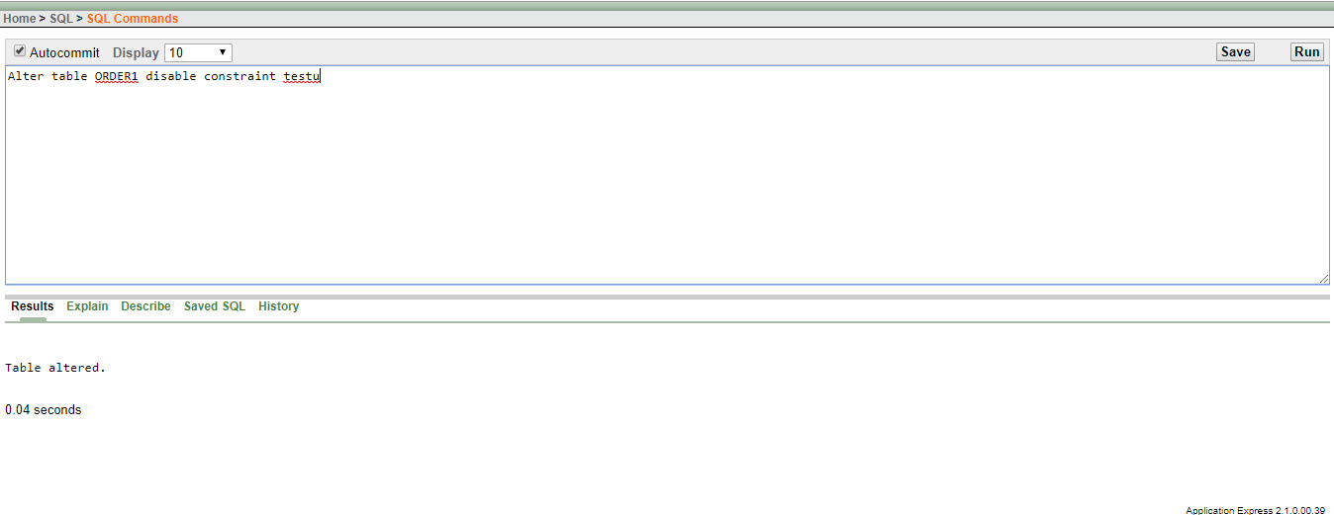

* **Drop constraint:**

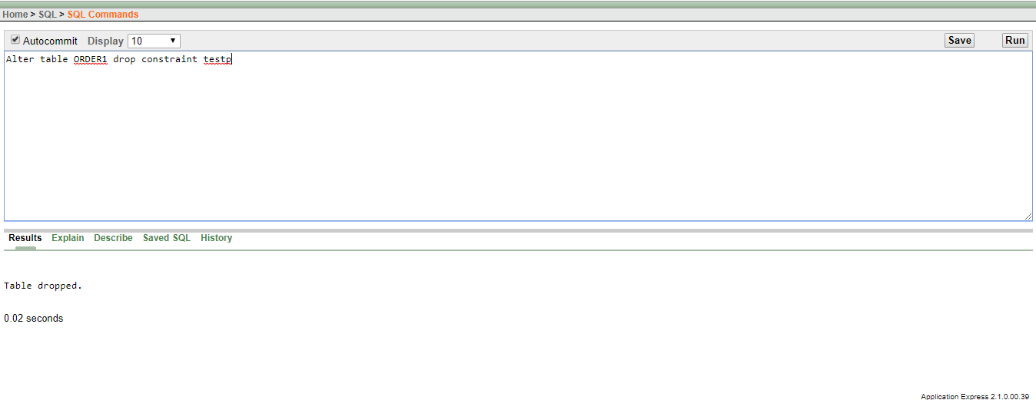

* **NULL constraint:**

